Understanding the IMC RBNQA Criteria
for Performance Excellence
1-day Workshop
19 April 2017 • 9.30 am to 5.00 pm
_______________________________________
IMC RBNQA Application Writing
2-day Workshop
20 & 21 April 2017 • 9.30 am to 5.00 pm

To promote the concept of Performance Excellence amongst Indian organizations, the IMC Ramkrishna Bajaj National Quality Award (RBNQA) Trust has planned a 1-day Workshop on Understanding the IMC RBNQA Criteria. The workshop prepares potential applicants for the IMC RBNQA 2017 competition.

The target audience for the workshop are CEOs, Division Heads, Function Heads and General Managers. The scope of the workshop includes understanding each of the seven IMC RBNQA criteria: Leadership; Strategic Planning; Customer Engagement; Workforce Engagement; Knowledge Management; Process Management and Results.

This workshop will be followed by a 2-day program focusing on Application Writing exclusively.

We wish to invite your organization to participate in the IMC RBNQA 2017 cycle and explore a holistic approach to understand your organization’s strengths and opportunities. These complimentary workshops will provide adequate exposure to enable you to take ‘the’ decision (Registration Form attached).

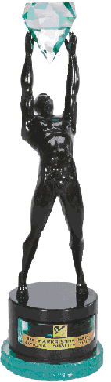

REGISTRATION FORM

19 April 2017: Understanding the IMC RBNQ Award Criteria Workshop

9.30am-5.00pm

20 & 21 April 2017: Workshop on Application Writing

9.30am-5.00pm

Venue: Walchand Hirachand Hall (4th floor)

IMC Chamber of Commerce & Industry

IMC Building, Churchgate, Mumbai 400 020

1 Organization: | _________________________________________
2 Address: | _________________________________________
 | _________________________________________
 | _________________________________________
 | _________________________________________
3. Participants:

Name: ____________________________ | Designation: ______________________________
Name: ____________________________ | Designation: ______________________________
4 Tel/Cell: ___________________________ | Email: ___________________________________

Contact:
R K Karkera
Sr Executive Assistant
Tel: 022 22025439/22046633 ext.602

